+*-



**LAB MANUAL**

**OPEN SOURCE TECHNOLOGY FOR COMMUNICATION**

ECL504

**PREPARED BY**

**Prof. Tanu Sharma**

**Prof. Shilpa Jaiswal**

**Department of Electronics & Telecommunication**

**YEAR: 2018-2019**

**(ODD)**

**LIST OF EXPERIMENTS**

|  |  |
| --- | --- |
| **S.No.** | **EXPERIMENT** |
|  | **Based on SCI_LAB software platform** |
| 1 | Write a program to generate basic functions on SCI Lab. |
| 2 | Write a program to perform convolution on a given signal. |
| 3a) | Write a program to plot the FSK wave form. |
| 3b) | Write a program to convert analog to digital signal. |
|  | **Based on LT-SPICE software Platform** |
| 4 | Design and simulation of basic op-circuits like inverting amplifier |
| 5 | Design and simulation a low pass and high pass filters. |
| 6 | Design and simulation of non-linear op amp like square wave generator |
|  | **Based on LT-Xilinx software Platform** |
| 7 | Write a program to design 1 bit full adder. |
| 8 |  |
| 9 | **Design mini project based on any of the above technology software.** |
| 10. | **Presentation of mini project based on any of the above technology software.** |

**SUBJECT: OPEN SOURCE TECHNOLOGY COMMUNCATION LAB**

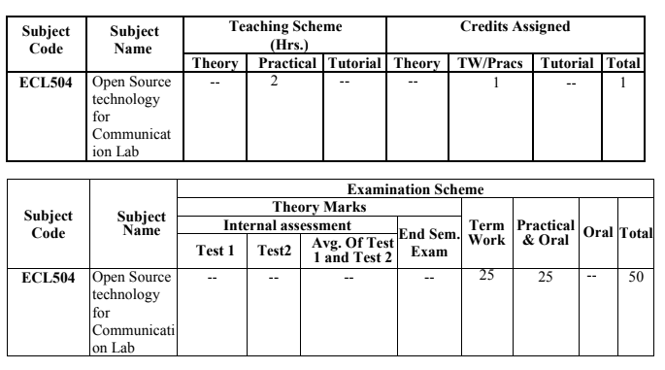

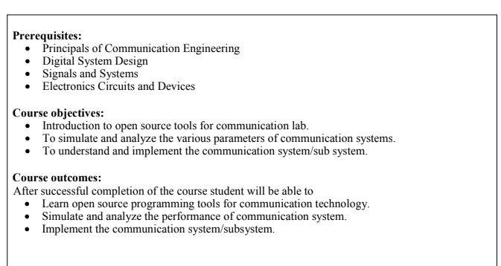

NAME OF STUDENT: ________________________________________________________

ROLL NO: ___________________________________________________________________

CLASS: _____________________________ BATCH:_______________________________

EXPERIMENT NO.1

Write a program to generate basic functions on SCI Lab.

DATE OF PERFORMANCE:

DATE OF CORRECTION:

SIGNATURE:

|  |  |  |
| --- | --- | --- |
| **Particulars** | **Max. Marks** | **Marks Obtained** |
| Practical Performance | 05 |  |
| Practical checking | 05 |  |
| Total | 10 |  |

**AIM:**  Write a program to generate basic functions on SCI Lab.

**THEORY: SCI-LAB**

**Benefit of using SCI-LAB**

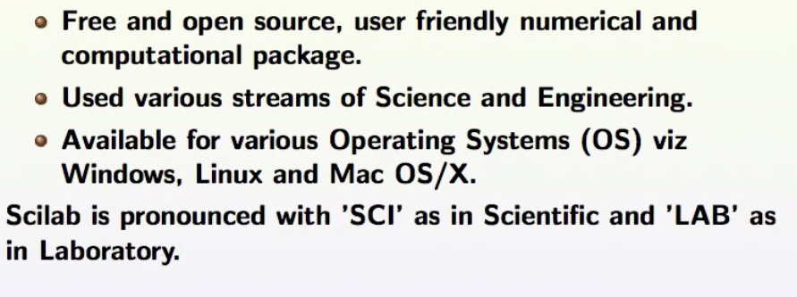

**Introduction:**

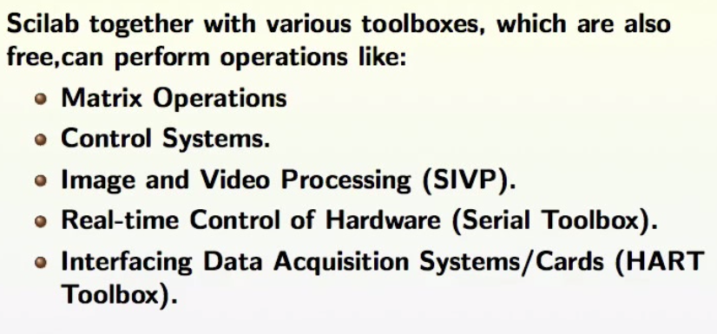

**Program code:**

**i) Find the area of triangle:**

clc;

a=input("enter lenght=");

b=input("enter breadth=");

area=0.5*a*b;

disp(area);

**ii)Basic commands:**

clc;

x=input("enter decimal value=");

y=dec2bin(x);

disp(y);

z=input("enter binary value=");

p=bin2dec(z);

disp(p);

q=input("enter binary value in a row=");

r=bin2dec(q);

disp(r);

**Output:**

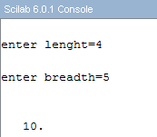

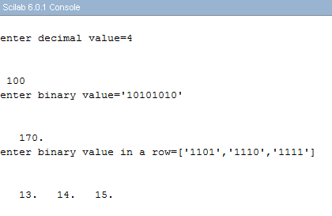

**QUESTIONS:**

**Q. Write program for basic commands on mathematical analysis on SCI-LAB.**

NAME OF STUDENT: ________________________________________________________

ROLL NO: ___________________________________________________________________

CLASS: _____________________________ BATCH:_______________________________

EXPERIMENT NO.2

Write a program to perform convolution on a given signal.

DATE OF PERFORMANCE:

DATE OF CORRECTION:

SIGNATURE:

|  |  |  |
| --- | --- | --- |
| **Particulars** | **Max. Marks** | **Marks Obtained** |
| Practical Performance | 05 |  |
| Practical checking | 05 |  |
| Total | 10 |  |

**AIM:**  **Write a program to perform convolution on a given signal.**

**THEORY:**

The input-output characteristic of linear time-invariant (LTI) systems, the most widely used type of system in signal processing, is described entirely in terms of the impulse response of the system.  The impulse response is the output of the system due to an impulse input signal.  Given the input signal, the output of an LTI system is the convolution of the input signal with the impulse response of the system.  Hence, convolution plays a key role in relating the input and output signals of an LTI system.

A linear system's characteristics are completely specified by the system's impulse response, as governed by the mathematics of convolution. This is the basis of many signal processing techniques. For example: Digital filters are created by *designing* an appropriate impulse response. Enemy aircraft are detected with radar by *analyzing* a measured impulse response. Echo suppression in long distance telephone calls is accomplished by creating an impulse response that *counteracts* the impulse response of the reverberation

**Program code:**

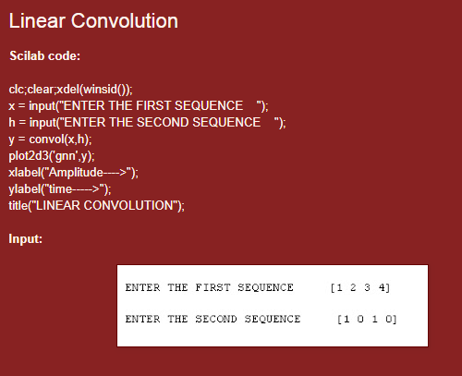

**Output:**

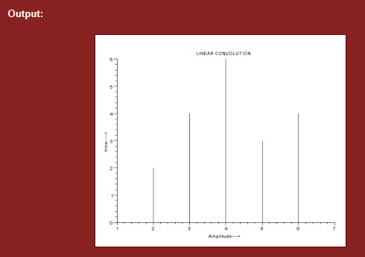

NAME OF STUDENT: ________________________________________________________

ROLL NO: ___________________________________________________________________

CLASS: _____________________________ BATCH:_______________________________

EXPERIMENT NO. 3(a)

Write a program to plot the FSK wave form.

DATE OF PERFORMANCE:

DATE OF CORRECTION:

SIGNATURE:

|  |  |  |
| --- | --- | --- |
| **Particulars** | **Max. Marks** | **Marks Obtained** |
| Practical Performance | 05 |  |
| Practical checking | 05 |  |
| Total | 10 |  |

EXPERIMENT NO. 3(a)

**Aim: Write a program to plot the FSK wave form.**

**THEORY:**

**Frequency Shift Keying (FSK)** is the digital modulation technique in which the frequency of the carrier signal varies according to the digital signal changes. FSK is a scheme of frequency modulation.

The output of a FSK modulated wave is high in frequency for a binary High input and is low in frequency for a binary Low input. The binary **1s** and **0s** are called Mark and Space frequencies.

The following image is the diagrammatic representation of FSK modulated waveform along with its input.

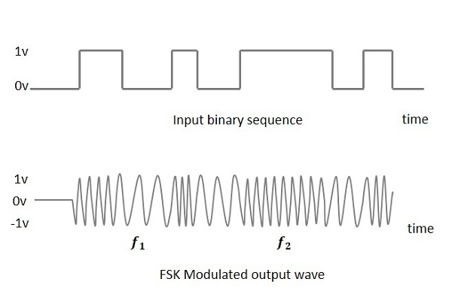

To find the process of obtaining this FSK modulated wave, let us know about the working of a FSK modulator.

**Program Code:**

clear;

clc;

f=input('enter the analog carrier frequency in Hz:');

t=0:1/512:1;

x=sin(2*%pi*f*t);

l=input('enter the binary digital data:');

fsk=[];

x1=sin(2*%pi*f*t);

x2=sin(2*%pi*(2*f)*t);

for n=1:length(l)

if(l(n)==1)

fsk=[fsk,x1];

elseif(l(n)~=1)

fsk=[fsk,x2];

end

end

plot(fsk)

xtitle('frequency shift keying')

ylabel('amplitude in volts')

xlabel('frequency in hertz')

z

**Output:**

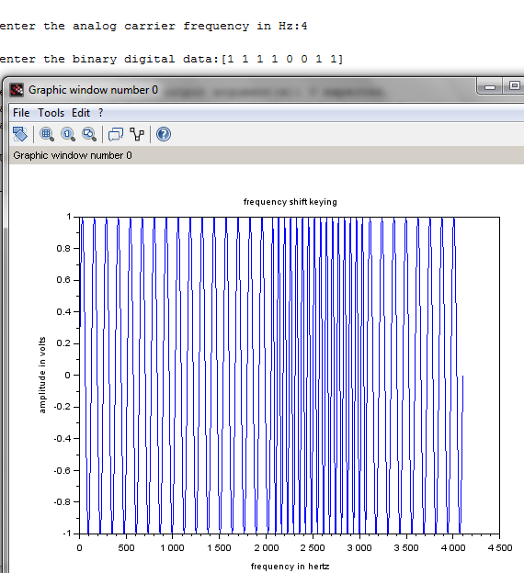

NAME OF STUDENT: ________________________________________________________

ROLL NO: ___________________________________________________________________

CLASS: _____________________________ BATCH:_______________________________

EXPERIMENT NO.3(b)

Write a program to convert analog to digital signal.

DATE OF PERFORMANCE:

DATE OF CORRECTION:

SIGNATURE:

|  |  |  |
| --- | --- | --- |
| **Particulars** | **Max. Marks** | **Marks Obtained** |
| Practical Performance | 05 |  |
| Practical checking | 05 |  |
| Total | 10 |  |

**AIM: Write a program to convert analog to digital signal.**

**THEORY:**

Analog-to-digital conversion is an electronic process in which a continuously variable ([analog](https://whatis.techtarget.com/definition/analog)) signal is changed, without altering its essential content, into a multi-level ([digital](https://whatis.techtarget.com/definition/digital)) signal.

 Examples are sine waves, the waveforms representing human speech, and the signals from a conventional television camera. The output of the ADC, in contrast, has defined levels or states. The number of states is almost always a power of two -- that is, 2, 4, 8, 16, etc. The simplest digital signals have only two states, and are called [binary](https://whatis.techtarget.com/definition/binary). All whole numbers can be represented in binary form as strings of ones and zeros.

**Program Code:**

**(analog )**

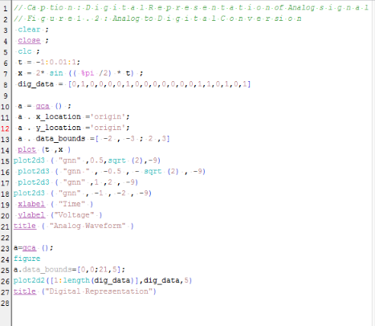

(Digital)

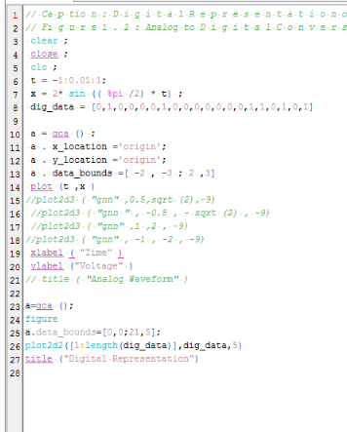

**Output:**

**(Analog)**

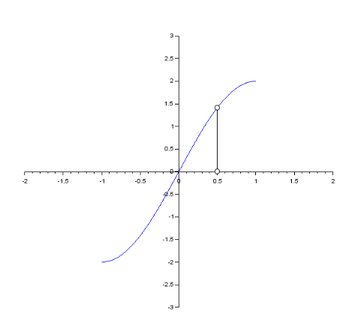

**(Digital)**

